

SIMATS ENGINEERING

Saveetha Institute of Medical and Technical Sciences
Chennai- 602105

Student Name: Roshne .V Reg. No.: 192421067
Course Code: CSA1750 Slot: Slot D
Course Name: Artificial intelligence for advanced technology
Course Faculty: Dr. G V Sriramakrishnan, Dr K Baskar
Project Title: AI -based smart noise awareness and environment monitoring system
Module Photographs: (3 photographs –Module Photo, Individual student contribution module work in the project and presentation image)
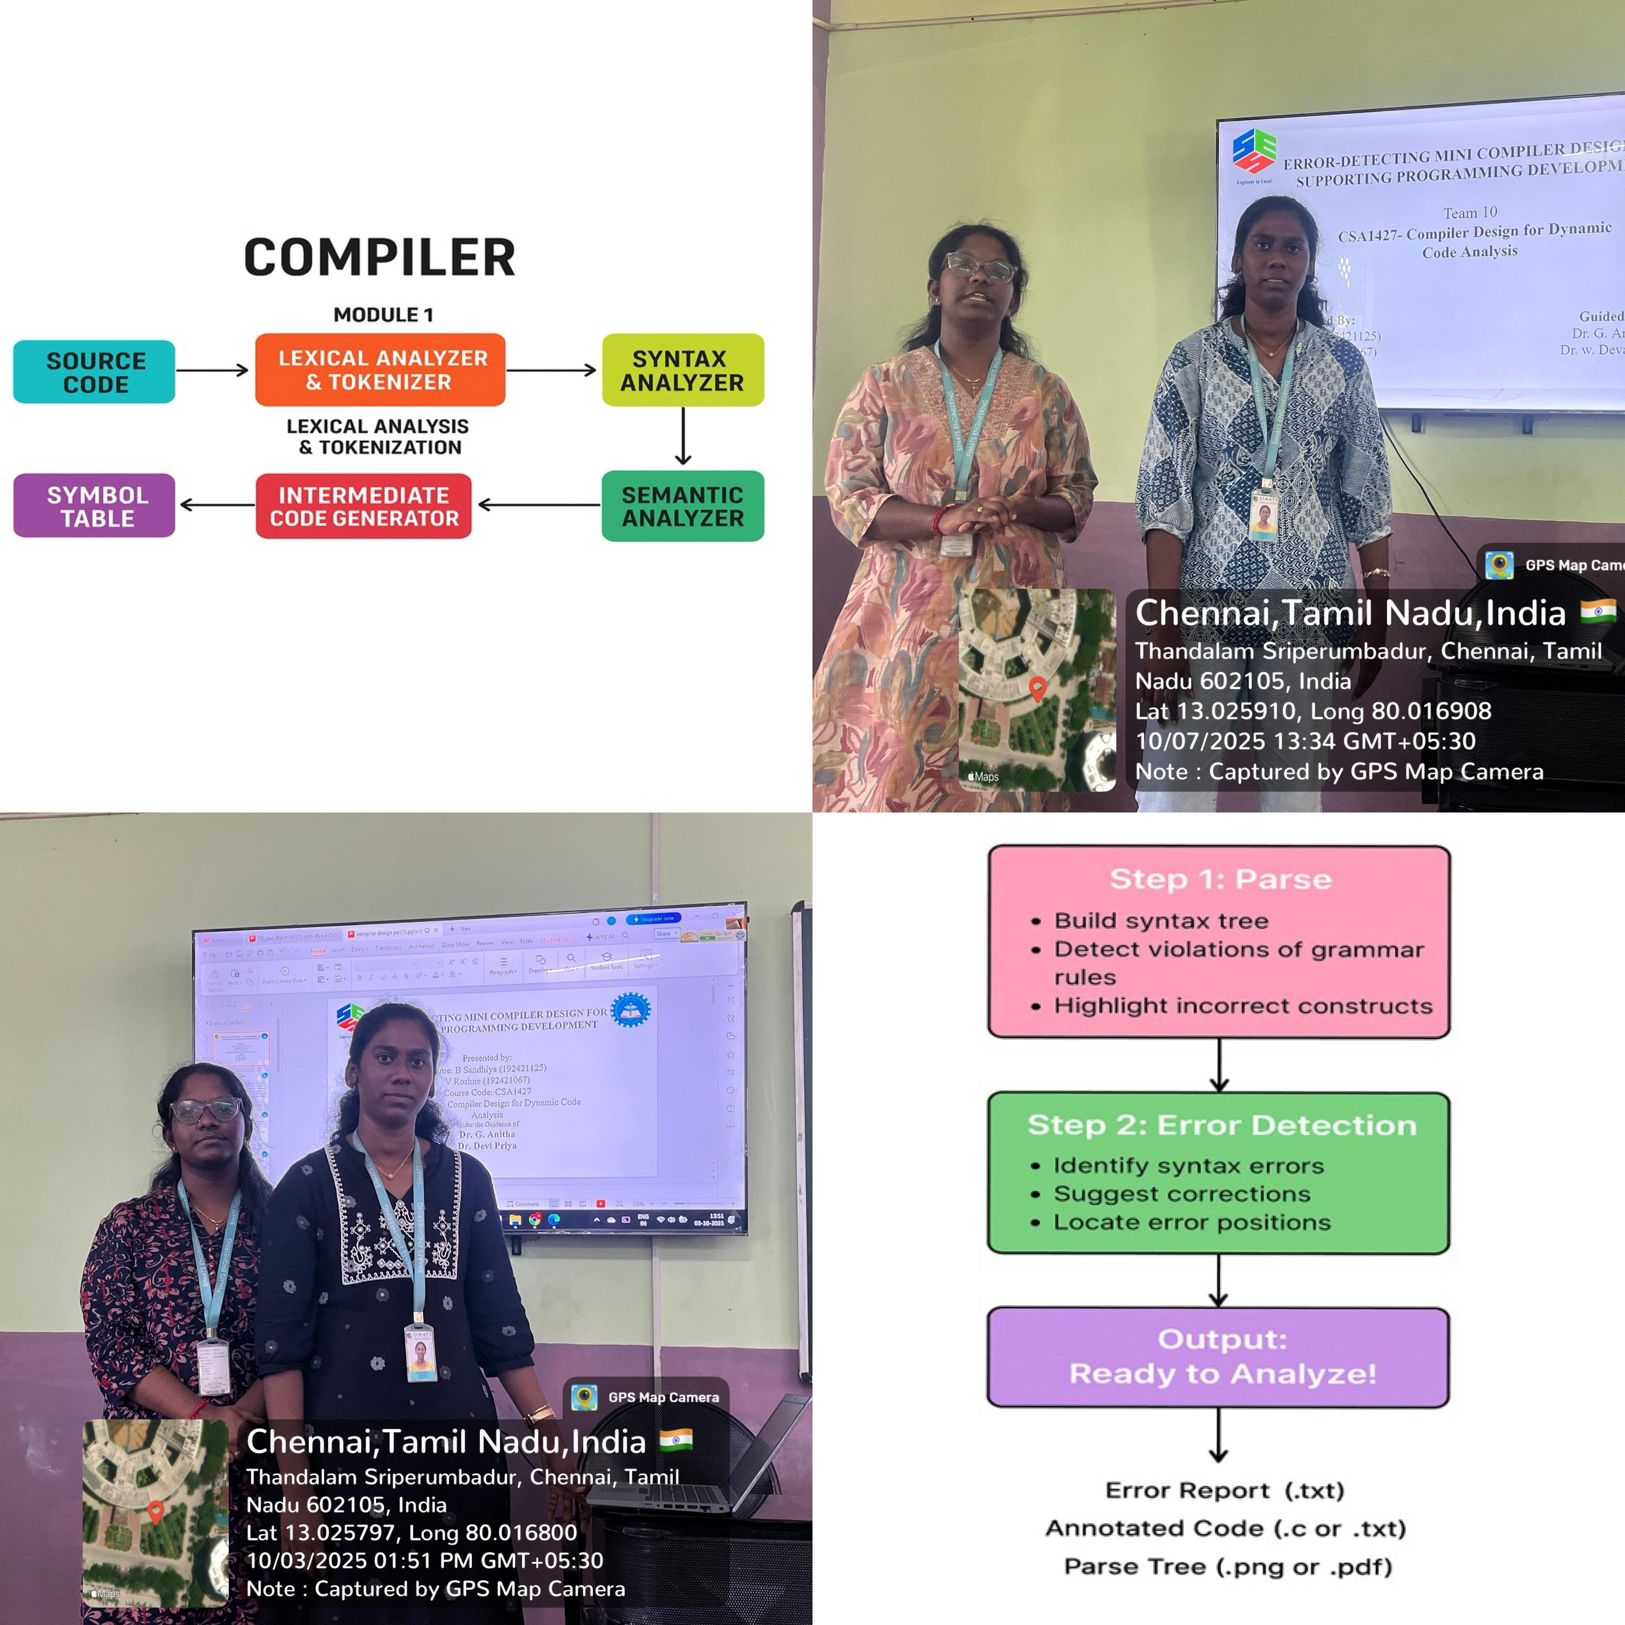
Project Description: (here you write what you did in this project (contribution) including Model Description
The AI-Based Smart Noise Awareness and Environment Monitoring System is designed to monitor environmental noise levels in real time and alert users when noise exceeds safe limits. The system uses a sound sensor to capture noise from the surroundings and an Arduino Uno to process the data using rule-based AI logic. The analog sound signals are converted into digital values and compared with a predefined threshold to classify noise as safe or excessive. When the noise level crosses the safe limit, a red LED is activated to indicate unsafe conditions, while it remains OFF during normal noise levels. The system is low-cost, reliable, and suitable for noise-sensitive areas such as classrooms, hospitals, and residential zones, with potential for future expansion using IoT and advanced AI techniques.

Student Signature Guide Signature

